**Vanier College**

**Faculty of Science and Technology**

**System Development**

**420-940-VA**

**Deliverable 03**

**Yellow Team**

Le Le Wei

Yao Wu

Zheng Xue

Shun Zi Yao

Chun Mei Zhang

In collaboration with @ Balloons D’or 2023&Montreal Facebook

**We, the Yellow Team, certify that this assignment is our own work.**

I, Le Le Wei, student ID #1103244, certify that I have contributed to this deliverable, L.L.W.

I, Yao Wu, student ID #2395031, certify that I have contributed to this deliverable, Y.W.

I, Shun Zi Yao, student ID #2395028 certify that I have contributed to this deliverable, S.Z.Y.

I, Zhang Xue, student ID #2395035, certify that I have contributed to this deliverable, Z.X.

I, Chunmei Zhang, student ID #2395038, certify that I have contributed to this deliverable, C.Z.

**Table of contents**

**__________________________________________________________**

**Table of Contents**

**Executive Overview 1**

**Summary of the Client 3**

**Business Problem 4**

Appendix 1 **6**

Appendix 2 **11**

Appendix 3 **12**

**Works Cited 13**

### Executive Overview

This document highlights important documentation in relation to the website that will be constructed over the next few weeks.

The document begins with an overview of who our client is Chan Juan. Chan is a dynamic entrepreneur based in Montreal, where she operates a thriving event planning business specializing in crafting exquisite, handcrafted balloon decorations. Her artistry adds a touch of magic to a wide array of occasions, from intimate family gatherings to high-profile corporate events.

Meeting Client Needs:

To cater to the unique requirements of Chan's balloon-focused business, we have identified key functional requirements that will shape the development of the website:

Flexible Pricing: Customized balloon artistry often involves a degree of pricing uncertainty. Our platform will enable a collaborative pricing process, allowing buyers and customers to discuss and finalize details offline before making payments.

Effortless Inquiry: The website will be designed to offer customers a hassle-free experience when making inquiries and placing orders. Recognizing that each balloon decoration is a personalized creation, the platform will allow customers to consult and express their preferences with ease.

Administrator Access: Chan will have administrator privileges, granting her the ability to efficiently manage her online presence. As an administrator, she can add, modify, query, and delete products, ensuring her offerings are always up to date. Additionally, Chan can create in-store promotions, providing a dynamic shopping experience for her clientele.

Order Management: To streamline operations, our platform will feature comprehensive order management tools. Chan will have access to real-time order updates, query historical orders, and make necessary adjustments to order statuses as required.

After addressing the business challenges, this document delves into the operational processes that must be followed by clients, the server-side, and administrator to ensure the seamless functioning of the business. It outlines the steps for customers to add items to their cart, navigate the checkout process, which subsequently updates the database, enabling the seller to review, fulfill, and mark orders as shipped.

Following these operational processes, this document includes multiple appendices containing crucial documentation essential for the coding phase of this project. Appendix 1 contains the flow chart of the entire system. Appendix 2 contains the UML diagrams, which are use case diagrams. Appendix 3 contains the class diagram for the entire system.

### Summary of the Client

Our client, Chan Juan, is an enterprising small business owner based in Montreal. With a flair for creativity and a specialization in personalized balloon decorations, Chan adds a touch of magic to diverse events. From intimate family gatherings to corporate affairs, her bespoke balloon arrangements serve as captivating focal points.

However, she faces challenges, relying on traditional showcase methods due to the absence of an automated platform.

Recent sales growth has fueled her ambition to expand. Chan seeks a dedicated platform and effective marketing strategies to amplify her unique balloon artistry to a broader audience, cementing her presence in the event planning domain.

### Business Problem

The inability to respond to potential buyers in real time results in missed opportunities, limiting the business's growth potential. Our client, while excelling in the world of balloon artistry, grapples with challenges stemming from part-time business engagement. To address this, our customers can now leave their contact information, ensuring that once a buyer places an order, automatic email notifications are sent, enhancing communication efficiency.

Balloon products are personalized, so the price is not fixed. Therefore, the order can only be truly completed after the buyer finally implements his or her personalized requirements. Therefore, as the transaction process increases, the risk of transaction failure increases.

Our client seeks a comprehensive solution to bridge these gaps, enabling real-time customer interaction, flexible pricing structures, and efficient order processing. Such a solution will streamline the transaction process, fostering business growth and customer satisfaction.

Meeting Client Needs:

To cater to the unique requirements of Chan's balloon-focused business, we have identified key functional requirements that will shape the development of the website:

Flexible Pricing: Customized balloon artistry often involves a degree of pricing uncertainty. Our platform will enable a collaborative pricing process, allowing buyers and customers to discuss and finalize details offline before making payments.

Effortless Inquiry: The website will be designed to offer customers a hassle-free experience when making inquiries and placing orders. Recognizing that each balloon decoration is a personalized creation, the platform will allow customers to consult and express their preferences with ease.

Administrator Access: Chan will have administrator privileges, granting her the ability to efficiently manage her online presence. As an administrator, she can add, modify, query, and delete products, ensuring her offerings are always up to date. Additionally, Chan can create in-store promotions, providing a dynamic shopping experience for her clientele.

Order Management: To streamline operations, our platform will feature comprehensive order management tools. Chan will have access to real-time order updates, query historical orders, and make necessary adjustments to order statuses as required.

### Appendixes

**Appendix 1**

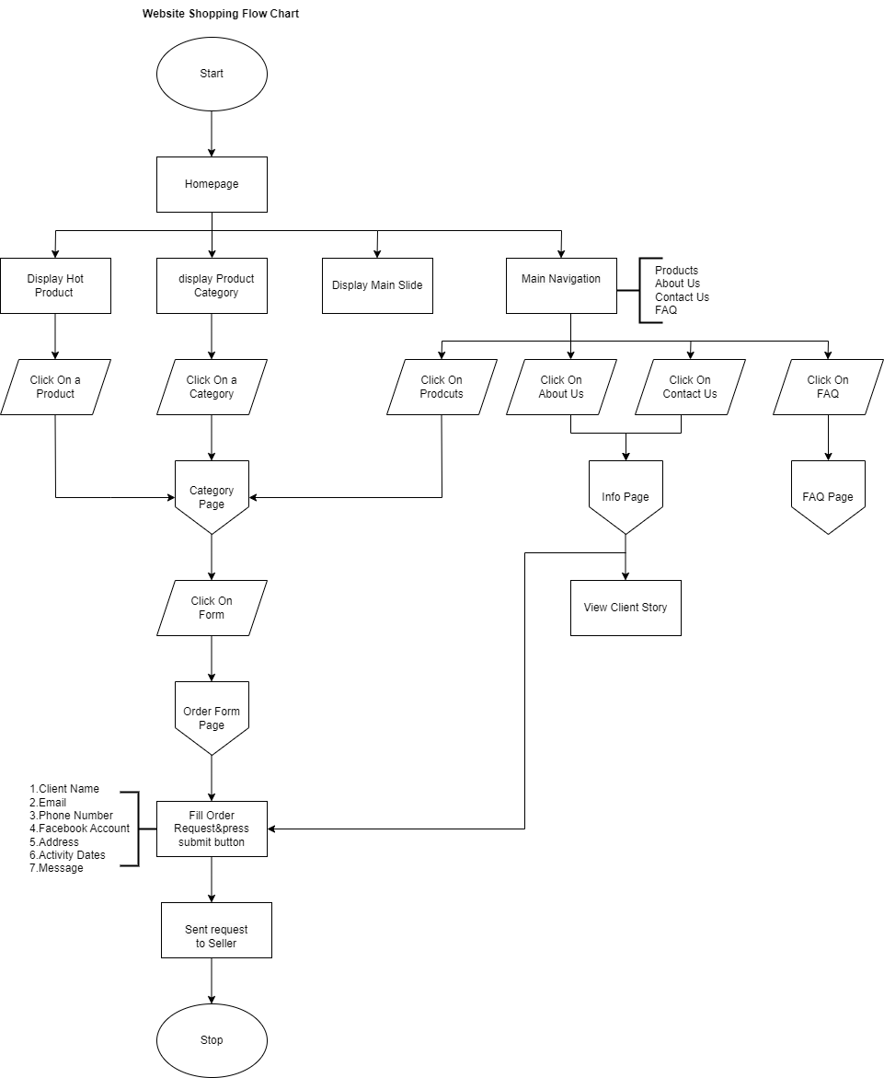

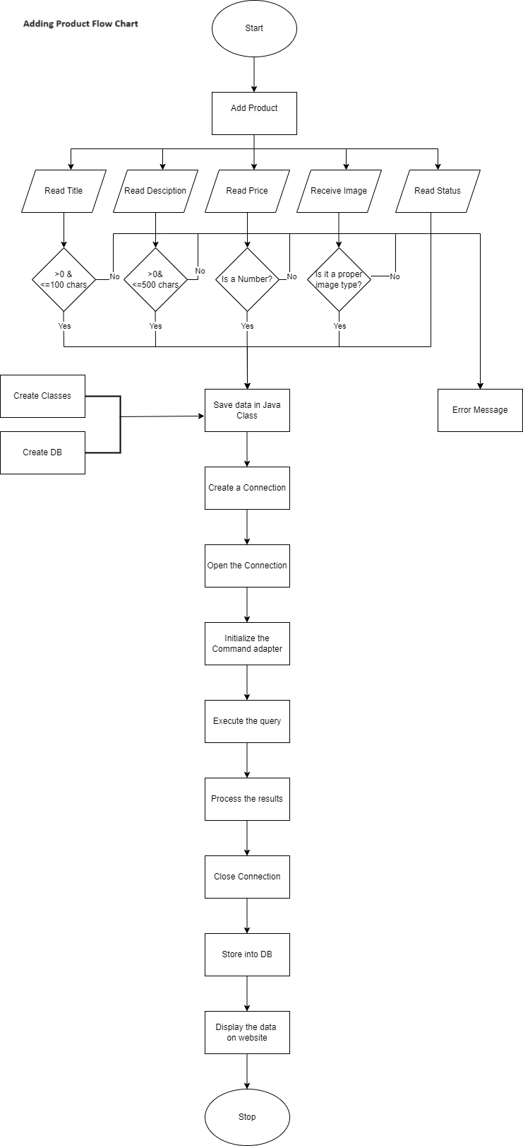

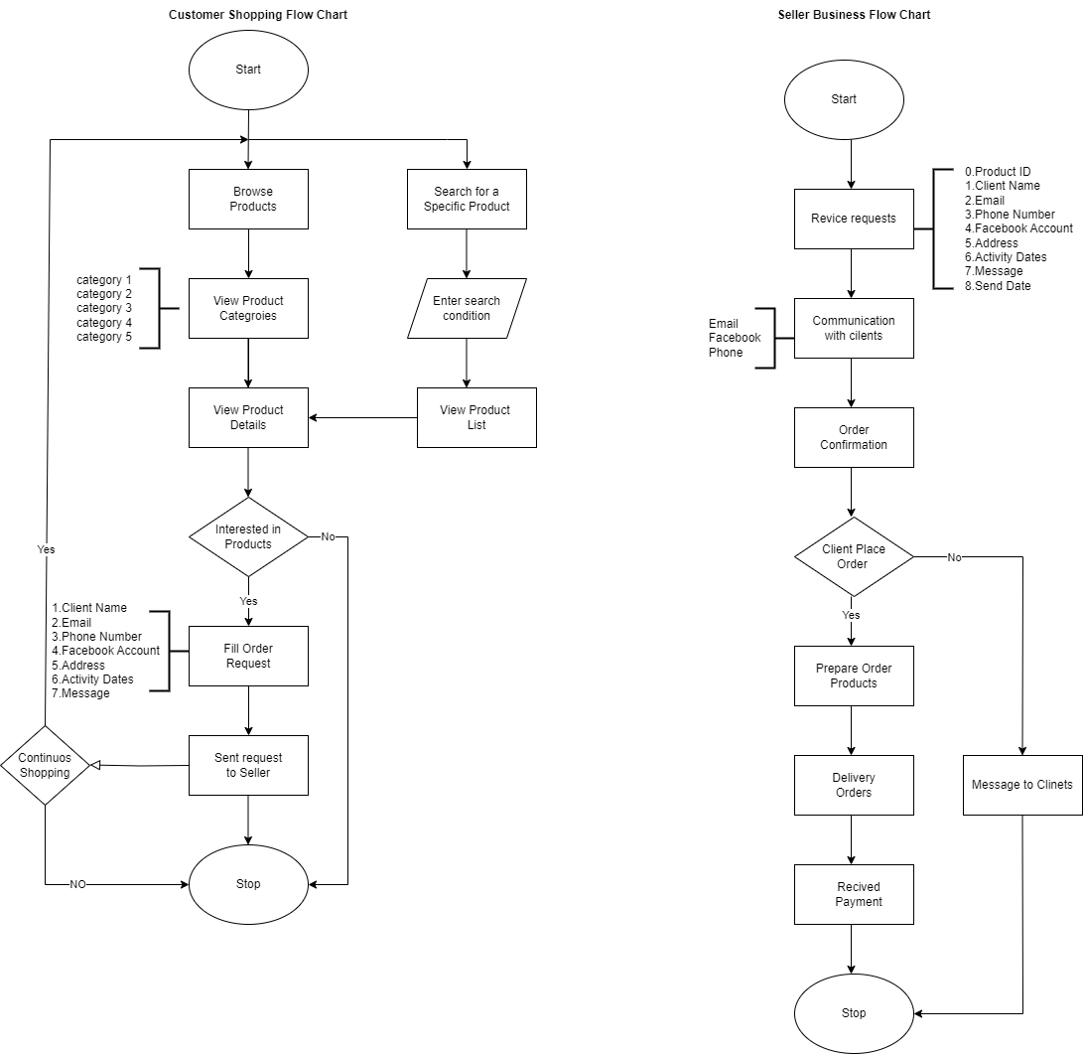

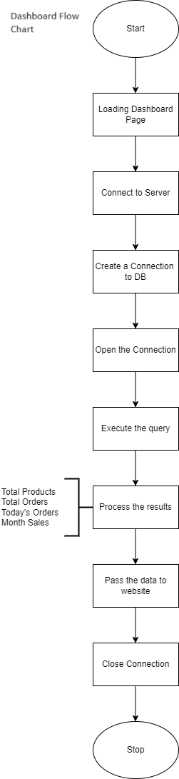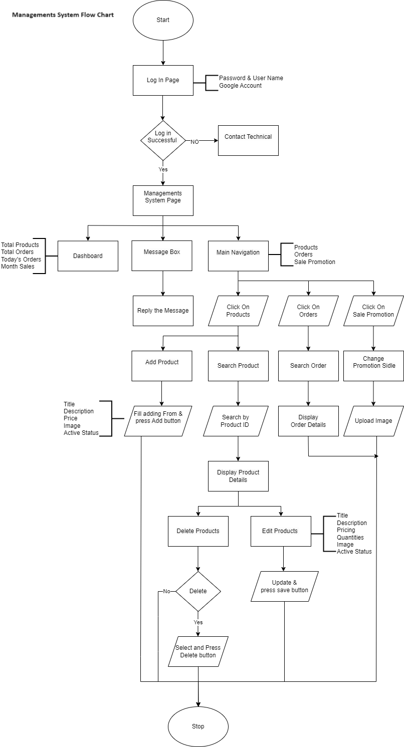

**Appendix 2**

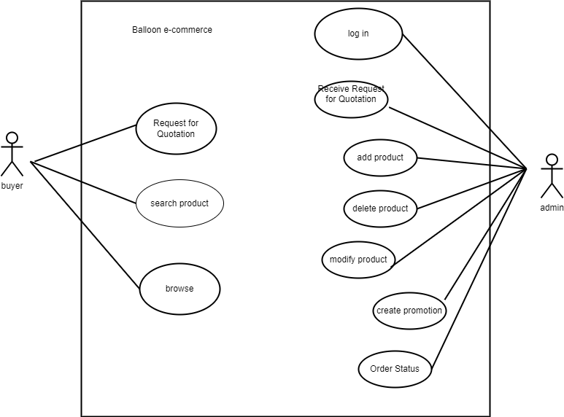

**Appendix 3**

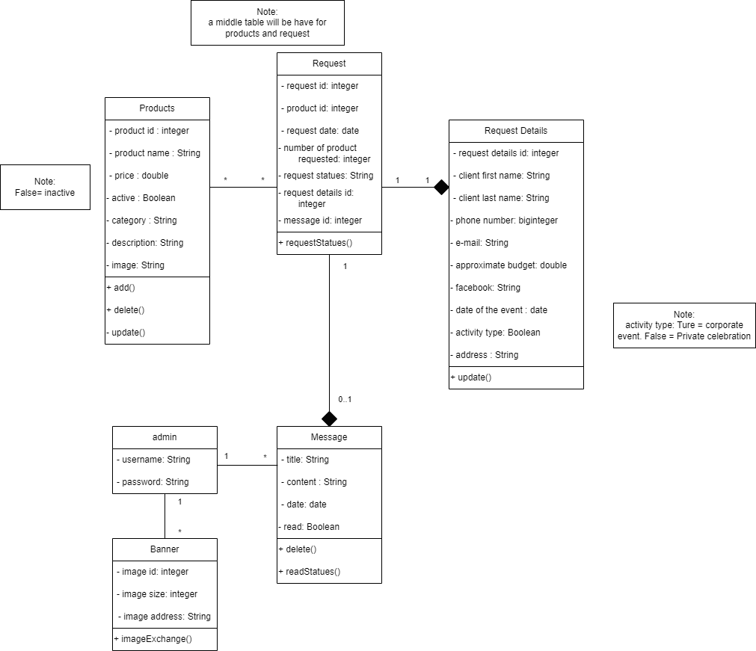

### Work Cited